1. 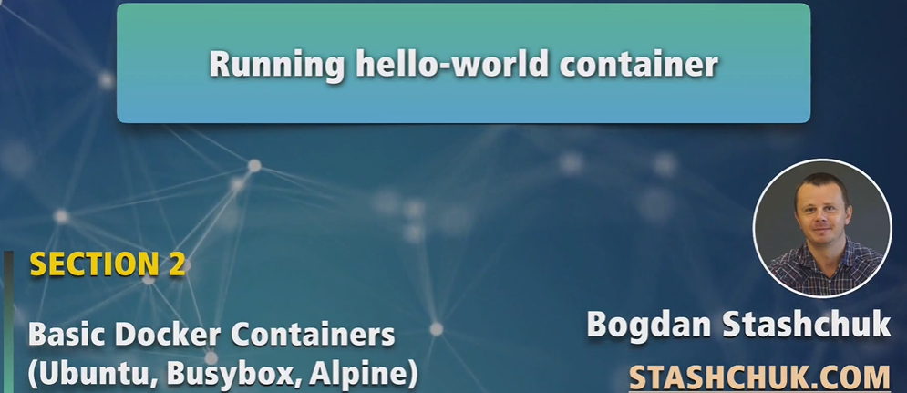
2. 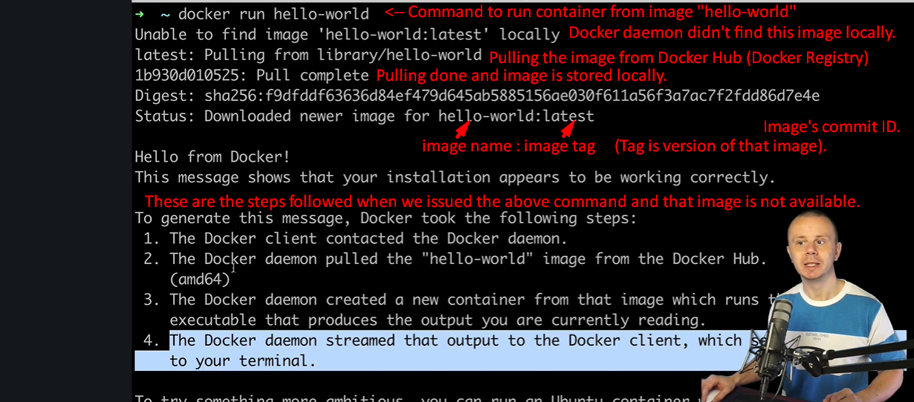
3. **NOTE**: Next time when you run this image, the pull request will not occur.
4. 